5YEY
Sequence (5’ to 3’) | $$ϵ_{260nm} (M^{-1}cm^{-1})$$ | DOI
GGGTTAGGGTTAGGGTTTGGG | 209100 | 10.1039/c8sc03813a

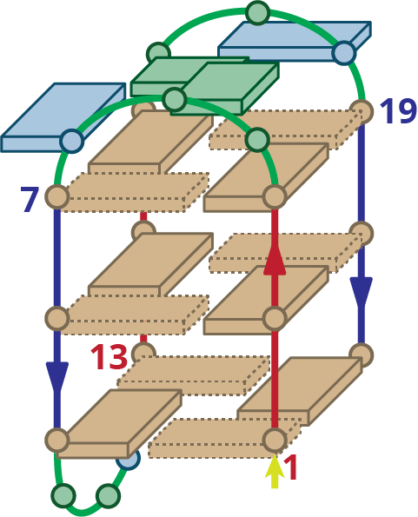
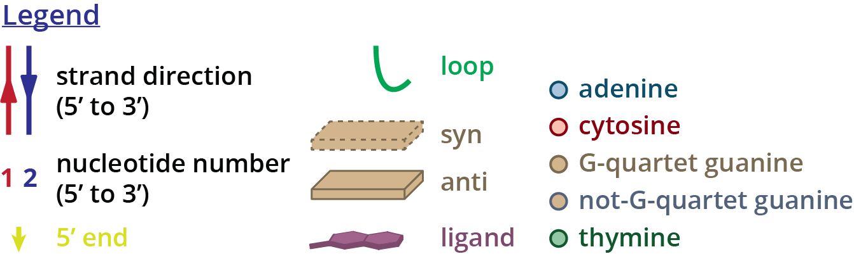
Structure diagram of 5YEY

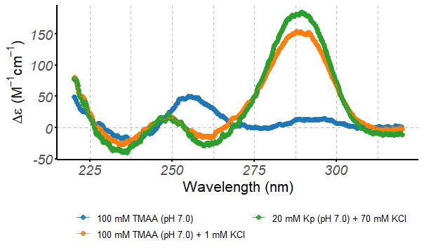
Circular dichroism spectra of the 5YEY oligonucleotide (10 µM), acquired at 25°C in 0.2-cm path-length cuvettes

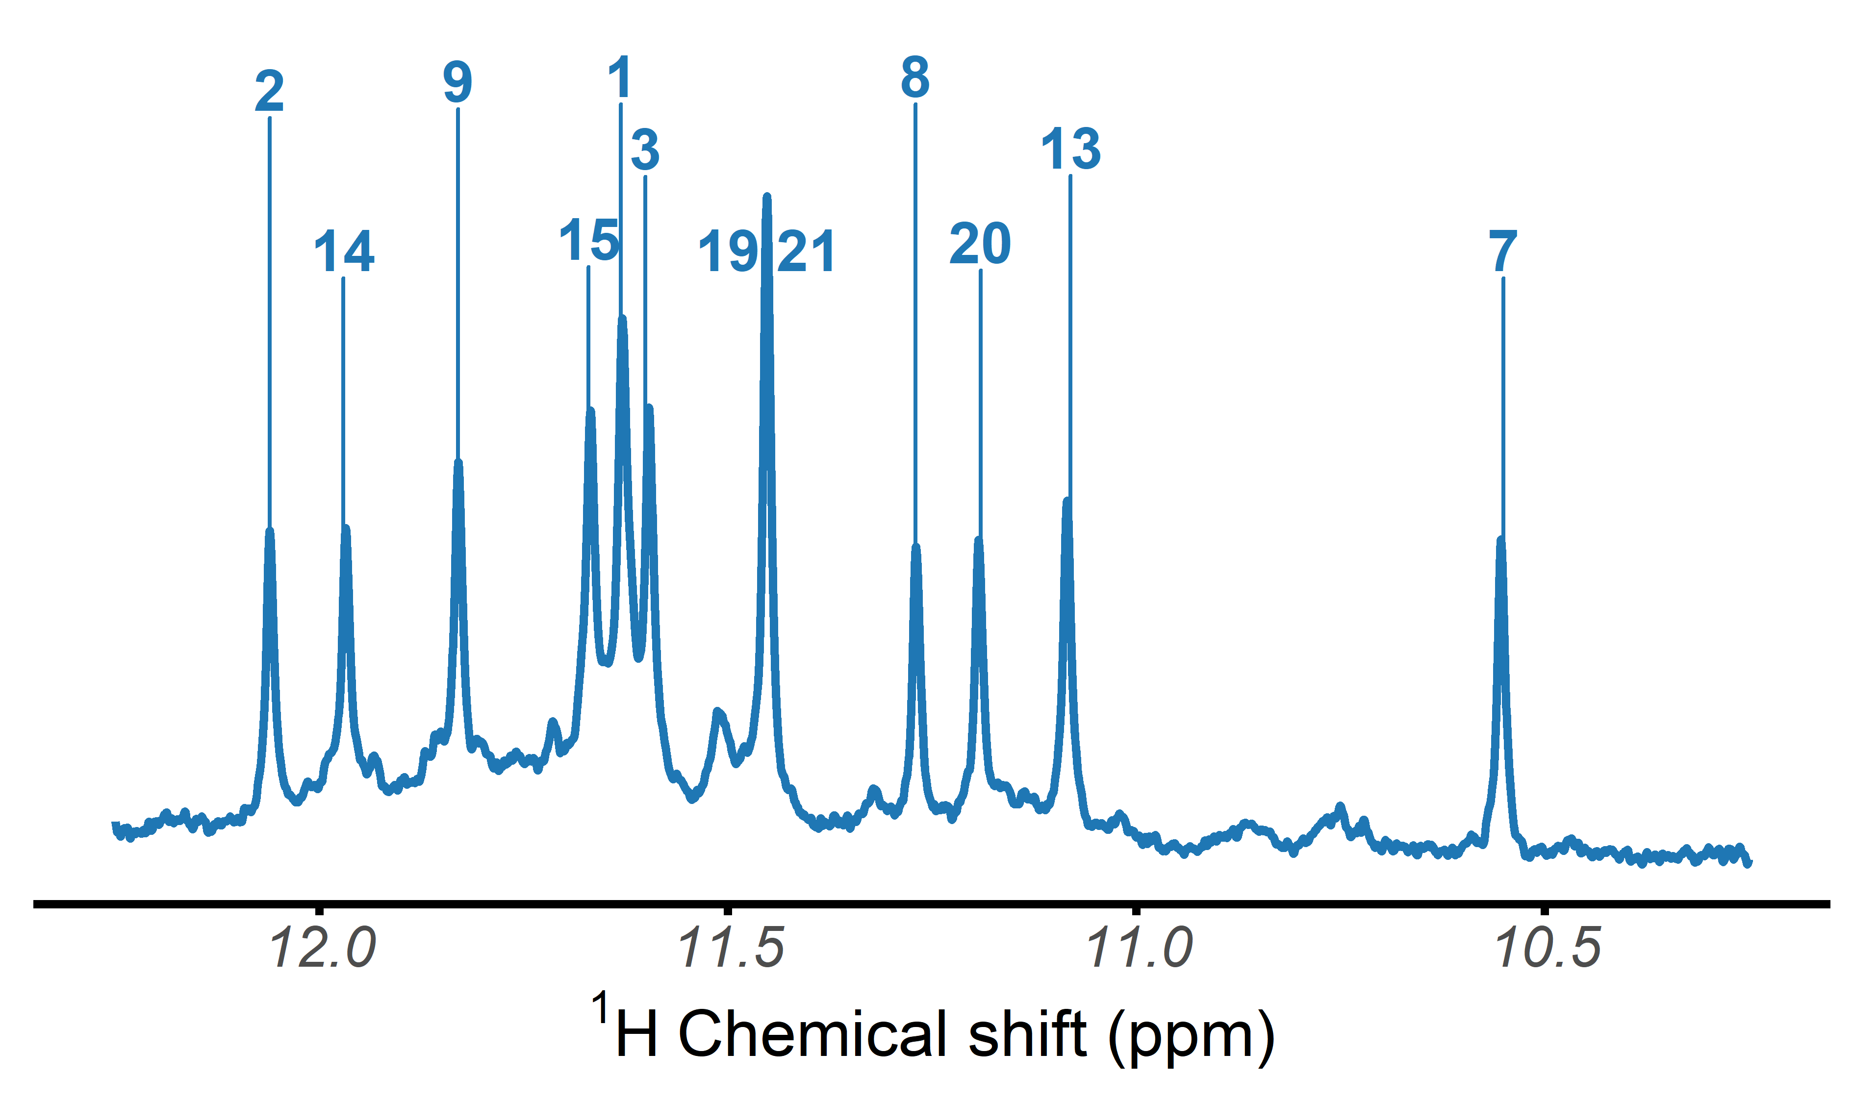
$​^{1}$H-NMR spectrum of the 5YEY oligonucleotide, acquired at 25°C in 100 mM TMAA (pH 7.0) + 1 mM KCl

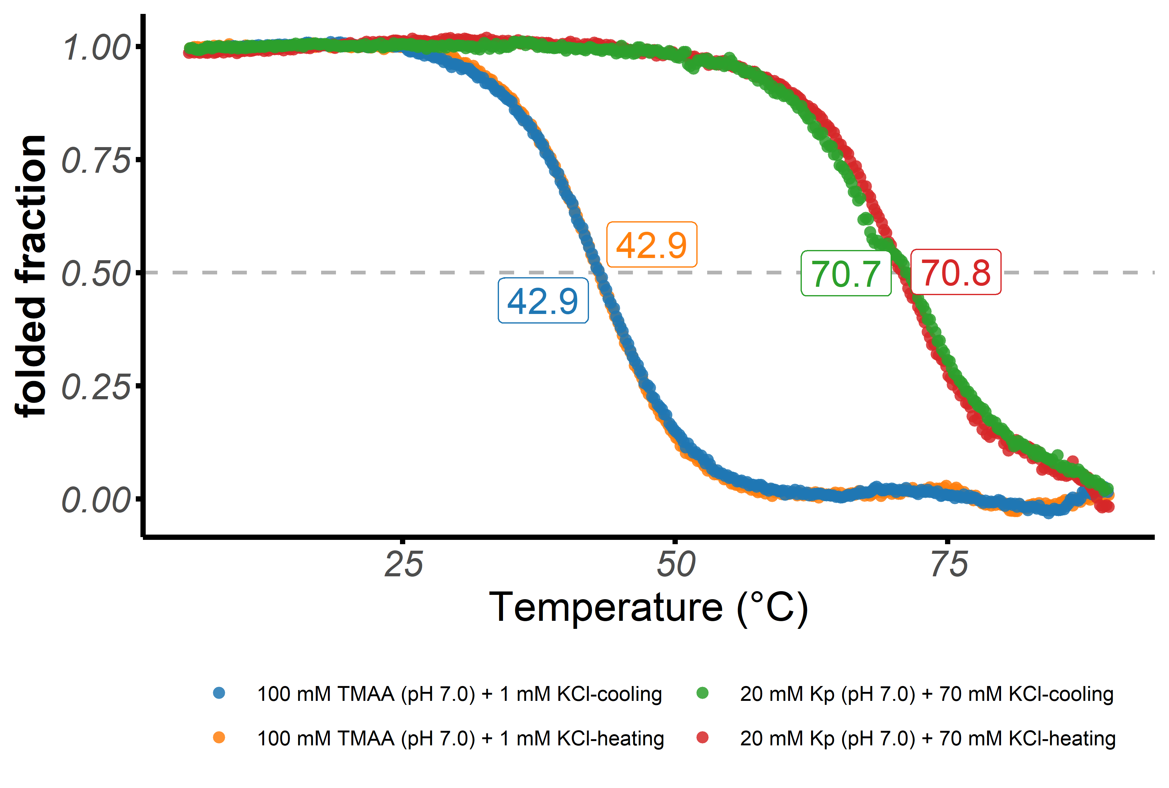
Folded fraction of the 5YEY oligonucleotide as a function of temperature, determined by UV-melting ($λ$ = 295 nm)

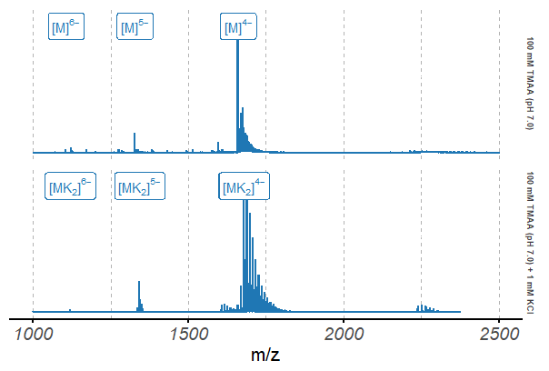
Native ESI-MS spectra of the 5YEY oligonucleotide (10 µM)

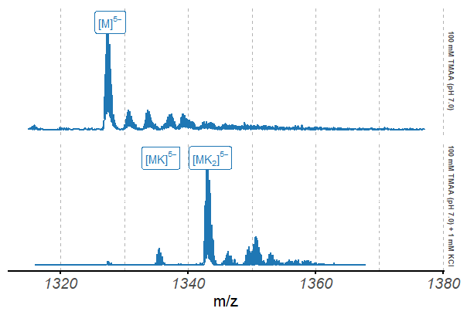
Native ESI-MS spectra of the 5YEY oligonucleotide (10 µM), focused on the 5$​^{-}$ charge state

